**PROJECT DESIGN PHASE-I**

**SOLUTION ARCHITECTURE**

|  |  |
| --- | --- |
| **DATE** | 16 October 2022 |
| **TEAM ID** | PNT2022TMID45909 |
| **PROJECT NAME** | Plasma Donor Application. |
| **MAXIMUM MARKS** | 4 Marks |



**SOLUTION ARCHITECTURE : Donor**



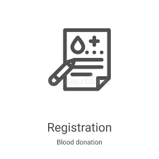



Send mail alerts

Login A Login B





Cloud database

IBM Watson Assistant (AI Bot)

Donor Allocate slot Donated details





registration

Donation center

**SOLUTION ARCHITECTURE:Recipient**   not available

 Check availability 

  cloud database Available

**Request order**

**Request registration**

**IBM Watson Assistant**

**Request**

**Donation center**

Request cloud